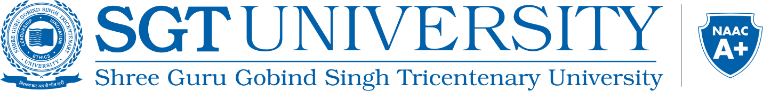

International Summit on Holistic Innovations for Nations’ Empowerment (I-SHINE-2025 AI)
Theme: Harnessing Artificial Intelligence for Sustainable Growth: Envisioning a Viksit Bharat by 2047
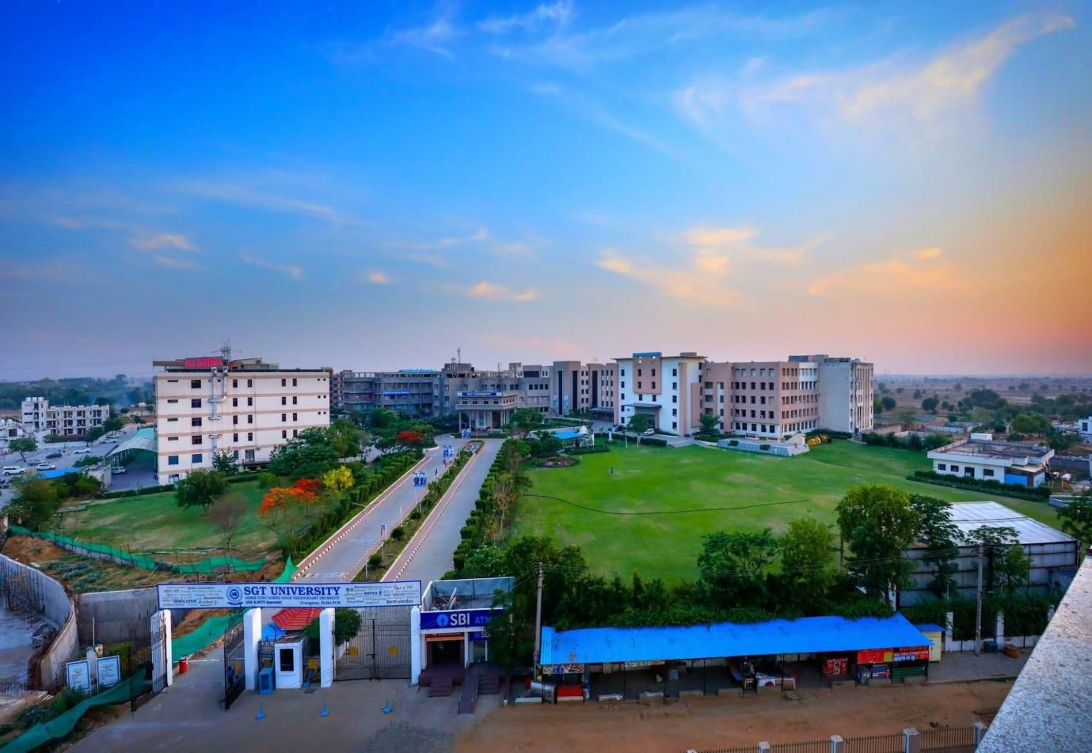

9th- 10thMay, 2025
Conference Venue: C Block, Auditorium
Conference Mode: Hybrid Mode

Organized by

Central Academic Clubs,
(SGT University)

Venue
SGT University, Gurgaon-Badli Road Chandu, Budhera, Gurugram, Haryana 122505

About the SGT University
SGT University is a UGC-recognized institution, established in 2013, that has broad ambitions to promote research, innovation, and multidisciplinary education. Our sizable campus, which is located on the outskirts of Gurgaon, spans more than 70 acres and has every type of resource and infrastructure available to facilitate optimum academic and research output. Our constant push for excellence led to us becoming one of the youngest universities to have received a NAAC A+ accreditation rating. Amongst our expansive range of specialties are our medical programs, taught in sync with SGT Medical College, Hospital & Research Institute, and considered to be some of the best in the country. SGT University offers courses across 18 faculties, including a variety of Undergraduate, postgraduate and PhD programs.
SGT University scaled horizontally by establishing Centre’s of Excellence like NRSC (National Reference Simulation Centre), CCSP (Centre for Cosmology Science & Popularization), CEAPS (Centre of Excellence for Andragogical and Pedagogical Sciences), and institutionalized CRC (Corporate Resource Centre), EDC (Entrepreneurship Development Centre), ACIC (Atal Community Innovation Centre), IIC (Institution's Innovation Council) - SGTU for focused attention and holistic development of students, faculty members, and Nation. Additionally, it has won a number of honors for its contributions to higher education, including the “Diamond Rating” from QSI- GAUGE and a “Diamond Band”from R world Institutional Ranking in the “Mental Health & Wellbeing” Category.
About the Central Academic Clubs, SGT University
Academics are an integral part of a student's life with an everyday learning experience, whether a graduate, post-graduate, or researcher. Shree Guru Gobind Singh Tricentenary University (SGTU) embarked on to promote academic activities at the campus through Academic Clubs. The Central Academic Clubs bring like minded students and teachers together with a common academic area of interest or academic objective, and provide such learning opportunities to students that they can’t acquire in the classroom. These student-driven platforms empower students to organize and participate in diverse academic activities, such as workshops and hands-on sessions. By extending learning beyond the regular curriculum, these clubs aim to enhance professional skills and foster holistic development outside the classroom.
Academic Clubs support innovative ideas of the students by providing them a platform to explore and experiment in any interdisciplinary model – aligned with the National Educational Policy (NEP) 2020. SGTU established Academic Clubs within various faculties and departments starting from the 2019-20 academic session to promote academic engagement.There are "eighty" Academic Clubs, driven by the students, followed by a structured methodology, under the guidance of Advisor(s) and Co-advisor(s), with shared decisions and responsibility.
Anvaya is the dynamic student body of academic clubs at SGT University. Word Anvaya is a Sanskrit word that translates to Accordance. Anvaya, as a student academic body, signifies unity, harmony, and adherence to principles. It was formed on 7 May 2024, entrusted with the exhilarating role of unifying and guiding academic clubs across all 18 faculties. Its mission is to ignite intellectual curiosity and drive innovation, fostering a thriving and collaborative academic ecosystem that inspires students to reach new heights.

About the International Summit on Holistic Innovations for Nations’ Empowerment (I-SHINE 2025 – AI)
The International Summit on Holistic Innovations for Nations’ Empowerment (I-SHINE 2025 – AI) is a pioneering global conference that brings together leading researchers, academicians, policymakers, and industry experts to explore the transformative potential of Artificial Intelligence (AI) in fostering sustainable and inclusive growth. This summit serves as a platform for knowledge exchange, interdisciplinary collaboration, and innovation, aiming to envision a Viksit Bharat by 2047 through AI-driven advancements.
Conference Theme:
"Harnessing Artificial Intelligence for Sustainable Growth: Envisioning a Viksit Bharat by 2047"
As AI continues to reshape industries, revolutionize governance, and enhance quality of life, this conference will facilitate discussions on the ethical, social, and technological dimensions of AI in achieving national and global sustainability goals.
Conference Objectives:
- Foster Interdisciplinary Collaboration – Bringing together experts from academia, industry, and government to discuss AI-driven innovations.
- Address Global and National Challenges – Exploring AI applications in healthcare, education, environment, governance, and smart cities.
- Promote Ethical AI Development – Encouraging responsible AI frameworks to ensure transparency, fairness, and accountability.
- Showcase Cutting-Edge Research & Innovations – Providing a platform for original research, case studies, and breakthrough technologies.
- Bridge Academia and Industry – Facilitating partnerships to drive real-world AI implementations for economic and societal progress.
Conference Tracks and Themes:
Track 1: Ethical AI and Governance for Sustainable Growth
- Development of Ethical Frameworks for Trustworthy AI Systems
- Policy Formulation, Regulatory Mechanisms, and Governance Models for AI Deployment
- Privacy Preservation, Cybersecurity, and Data Sovereignty in AI Ecosystems
- Cross-Disciplinary Approaches to AI Ethics and Responsible Innovation
- AI-Driven Justice Systems: Ensuring Fairness, Accountability, and Transparency
- Social and Cultural Dynamics of AI Integration in Diverse Societies
- Advanced Research Trends in Ethical and Responsible AI
Track 2: AI in Healthcare and Biomedical Sciences
- AI-Driven Innovations in Diagnostics, Early Detection, and Precision Medicine
- AI in Computational Biology and Personalized Therapeutics
- Automation in Healthcare Systems: Smart Hospitals and Robotics
- AI Applications in Public Health, Epidemiology, and Global Health Initiatives
- AI in Mental Health Monitoring, Intervention, and Personalized Well-being
- Ethical Considerations and Regulatory Challenges in AI-Powered Healthcare
- AI Integration in Allied Health Sciences, Complementary Medicine, and Wellness
- Advancing Forensic and Biomedical Sciences Through AI Solutions
- AI in Ayurveda, Naturopathy and Yogic Sciences.

Track 3: AI for Environmental Sustainability and Agricultural Innovation
- AI Technologies for Climate Modeling, Carbon Tracking, and Resilience Building
- Precision Agriculture: AI-Enhanced Soil Health Monitoring, Crop Management, and Pest Control
- AI-Driven Sustainable Water Resource Management and Smart Irrigation Systems
- Leveraging AI for Sustainable Supply Chain Optimization in Agri-Food Systems
- Energy-Efficient AI Models for Green Computing and Renewable Energy Integration
- Case Studies and Best Practices in AI Applications for Environmental and Agricultural Sustainability
- AI in Disaster Mitigation and Resource Conservation
Track 4: AI for Education, Creativity, and Industrial Transformation
- Transformative Role of AI in Education, Lifelong Learning, and Workforce Development
- Enhancing Accessibility and Inclusion through AI Solutions
- AI for Advanced Business Analytics, Financial Modeling, and Economic Growth
- Industrial Revolution 4.0: AI in Manufacturing Processes and Automation
- AI in Creative Domains: Computational Arts, Music Generation, and Storytelling
- AI-Driven Innovations in the Pharmaceutical and Food Industries
- AI Applications in Hospitality, Tourism, and Luxury Markets
- Synergies Between Cognitive Sciences and AI Research in Pedagogy and Innovation
Track 5: AI for Smart Cities, Urban Systems, and Future Mobility
- AI-Powered Urban Planning, Resource Optimization, and Governance in Smart Cities
- Advanced AI Applications in Transportation, Logistics, and Autonomous Mobility
- AI in Urban Analytics for Sustainable Infrastructure Development
- Vision Systems and Image Processing for Smart Cities and Public Safety
- Integrating AI into Public Policy Design for Sustainable Urban Ecosystems
Track 6: Interdisciplinary AI Research and Emerging Technologies
- AI and Emerging Technologies: Synergies with IoT, Blockchain, and Robotics in Micro-manufacturing
- AI-based design and optimization of functional materials.
- Case Studies in Multidisciplinary AI Research for Sustainable Development
- AI for Precision Engineering and Advanced Computational Systems.
- AI based Micro-manufacturing for sustainable engineering.
- AI and Machine Learning Applications in Physical, Chemical, and Biological Sciences
- AI Contributions to Space Exploration, Cosmology, and Astrophysical Research
- Behavioral and Social Sciences in the AI Era: Interdisciplinary Opportunities and Challenges

Who Should Attend?
This summit invites participation from:
🎓 Academicians & Researchers – Present cutting-edge AI research and methodologies.
🏢 Industry Professionals & Entrepreneurs – Showcase AI-driven innovations for business and technology advancements.
🏛 Government Officials & Policymakers – Discuss AI’s role in shaping future policies and governance models.
📈 Startups & Innovators – Network and explore potential collaborations in emerging AI technologies.
🎯 Students & AI Enthusiasts – Gain insights into future career opportunities and AI-driven impact on society.
Paper Submission & Publications:
🔸 Authors are invited to submit original, unpublished research papers aligned with the conference theme.
🔸 Accepted papers will undergo peer review and be published in reputed Scopus-indexed journals (approval pending).
Why Attend I-SHINE 2025 – AI?
✔️ Gain insights from AI leaders and experts in academia, industry, and policy.
✔️ Network with global professionals and AI practitioners.
✔️ Present research findings, case studies, and innovative AI applications.
✔️ Discover funding, collaboration, and career opportunities in AI-driven fields.
Paper Submission Guidelines – I-SHINE 2025 – AI
The International Summit on Holistic Innovations for Nations’ Empowerment (I-SHINE 2025 – AI) invites researchers, academicians, industry professionals, and policymakers to submit original, high-quality research papers aligned with the conference theme "Harnessing Artificial Intelligence for Sustainable Growth: Envisioning a Viksit Bharat by 2047."
  - Important Dates:
📅Abstract Submission Deadline: 15 March 2025
📅 Paper Submission Deadline: 10 April 2025
📅 Notification of Acceptance: 20 April 2025
📅 Camera-Ready Paper Submission: 30 April 2025
📅 Conference Dates: May 9–10, 2025
  - Submission Categories:
We welcome submissions in the following categories:
📌 Full-Length Research Papers – Original research contributions.
📌 Review Papers – Comprehensive surveys on AI-related topics.
📌 Case Studies & Industry Applications – AI-driven solutions in real-world scenarios.
  - Paper Formatting Guidelines:
🔹 Papers must be written in English and formatted according to the IEEE Conference Template.
🔹 Page Limit: 6–8 pages (including figures, tables, and references).
🔹 Font & Spacing: Times New Roman, 10 pt, single-column format.
🔹 Reference Style: IEEE citation format.
🔗 Download IEEE Template: [Link will be provided]
  - Submission Process:
📥 Step 1: Prepare the manuscript according to the IEEE format.
📥 Step 2: Submit your paper through the EasyChair Conference Management System [Submission Link – To be Updated].
📥 Step 3: Papers will be subjected to a double-blind peer-review process.
📥 Step 4: Authors of accepted papers must submit the camera-ready version with revisions as per reviewer comments.
  - Review Process & Publication:
✅ All submitted papers will undergo a double-blind peer-review process by experts in AI and related fields.
✅ Accepted papers will be published in Scopus-indexed journals (approval pending) or conference proceedings.
  - Ethics & Plagiarism Policy:
⚠️ Papers must be original and unpublished, with less than 10% plagiarism (checked via Turnitin).
⚠️ Simultaneous submission to multiple journals or conferences is strictly prohibited.
⚠️ Any paper found violating ethical guidelines will be rejected.
  - Contact for Submission Queries:
📧 Email: ishine2025@sgtuniversity.org
🌍 Website: [conference website link]
  - Registration Fees:
Registration* | Upto 25th March, 2025 | On the Spot
Undergraduate Students, Postgraduate Students and Ph. D. Scholars | Rs. 1400/- | Rs. 2000/-
Faculty Members/ | Rs. 1800/- | Rs. 2500/-
Delegates from Industry and Non-profit organizations | Rs. 2500/- | Rs. 3000/-
Overseas (UG/PG/PhD/Faculty/Industry) | US$ 30 | US$ 50
*The registration fee includes conference participation, conference kit, lunch, and dinner.

Payment Mode

Account Name:
A/c No: (15 Digits):
Type of Account:
RTGS / NEFT / IFSC Code:
Bank Name:
Bank Address:
Scan for payment

After paying the registration fees, visit the link given below to register for the conference: link

Accommodation
Accommodation would be available on prior information. It will be available in the university campus on a first come, first served, and payment basis. Rs. 350 per night for students on a sharing basis and Rs. 500 per night for faculty members. Other details will be provided in the paper acceptance communication.

Reward for outstanding papers
For promoting qualitative contribution in research and academics, best papers will be announced, and the certificates will be awarded.

PATRONAGE
Chief Patron
Padma Bhusan Shri. Ram Bahadur Rai (Hon’ble Chancellor)

Patrons
Shri. Manmohan Singh Chawla (Managing Trustee)
Smt. Madhu Preet Singh Chawla (Chairperson)

Co-Patron
Prof. (Dr.) Madan Mohan Chaturvedi (Vice Chancellor)

Mentors
Mr. Anil S Kumar Prof. (Dr.) Poornima Baliga Bantwal Dr. Atul Kumar Nasa
(CEO) Pro Vice-Chancellor Pro Vice-Chancellor

Dr. Joginder Yadav
Registrar

ORGANIZING COMMITTEE

Conference Chairperson Co-Chairperson
Dr. Omkar Shetty Dr. Vivek Srivastav
Dean and Professor Professor, MED, FEAT
ORGANIZING SECRETARIES

Dr. Bharti Raina
Convener Central Coordination Cell

Dr. Dinesh Deshwal
Faculty of Engineering and Technology

Dr. Nitesh Singh
Faculty of Agriculture Sciences

ORGANIZING JOINT SECRETARIES
Prof. (Dr.) Pulin Saluja, Faculty of Dental Science
Prof. (Dr.) Mamta, Faculty of Dental Science
Prof. (Dr.) Susmita Saha, Faculty of Medicine and Health Sciences
Ms. Nicky Tyagi, Faculty of Nursing

GUESTS

Prof. K K Aggarwal
President
South Asian University, New Delhi Inda

Prof. Mohammad Afhar Alam
Vice- Chancellor
Jamia Hamdard University, New Delhi

Dr. Indresh Kumar

Dr. Pratibha Singh
Program Manager, South Asia (ACIAR)

KEYNOTE SPEAKERS

Dr. Khalid Raza,Jamai Milia Islamia, India

Dr. Khalid Raza,Jamai Milia Islamia, India

Dr. Hari Prasad Kota,
Kumamoto University, Japan

Dr. Waqar M. Naqvi
International Faimer Institute Fello, Doha

Dr. Vikas Kannojiya
Harvard Medical School, USA

Mr. Nivedan Rathi,
Future & AI

Mr. Kishan Srivastava
SDLC Corp

Mr. Shivam Dwivedi

Dr. Kiran Chaudhary
Delhi University
SCIENTIFIC AND TECHNICAL COMMITTEE

ADVISORY COMMITTEE SGT MEMBERS
Dr. S.K Trigun
Dr. Waheeda Khan
Dr. Sumit Singh Phukela
Dr. Barkha Bhatnagar
Dr. Kamlesh Sharma
Dr. Pooja Pant
Dr. Sushma Chaturvedi
Prof. (Dr.) Prasanna V. Savanur
Dr. Dheeraj Bahl
Dr. Sangeeth Somanadhapai
Dr. Sunil Kumar Dular
Dr. Pooja Anand
Prof. (Dr.) Amra Ahsan
Prof. (Dr.) Kirti Dutta
Dr. Madhavi Sharma
Prof. Sanjay Kumar
Dr. Sukhvir Singh
Mr. Harish Kumar
Dr. Richa Chaudhary
Mr. Abhishek Dubey
Dr. Neha Sharma
Dr. Sarika Yadav
Dr. Ashwani Kumar Dwivedi
Mr. Harish Kumar
Dr. Ashima Rani
Dr. Pooja Gaba Adlakha
Dr. Sunita Sahish
Dr. Vidyavati V Hiremath
Dr. Siddhartha Sen
Dr. Madhula Sharma
ADVISORY COMMITTEE - NATIONAL

ADVISORY COMMITTEE – INTERNATIONAL
Dr. Vikas Kannojiya, Research Fellow (Jr. Scientist), Department of Cardiac Surgery, Boston Children’s Hospital, Havard Medical School
Dr. Mirna Mourtada-Maarabouni, Dean of Internationalisation and Partnerships, Faculty of Natural Sciences, Keele University, UK
Prof. Robert Green, OBE, University of Kent, UK

